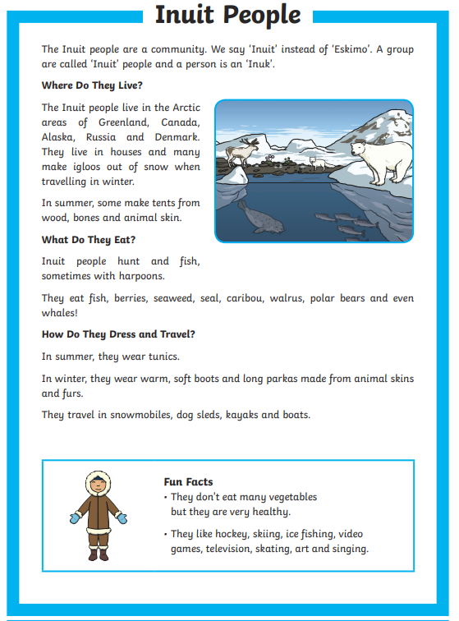

Questions:

What are ‘Inuit’ people?
____________________________________________________________________________

Where do Inuit people live?
____________________________________________________________________________

In the summer, what do they make their tents from?
____________________________________________________________________________

What do they eat? How do they hunt?
____________________________________________________________________________

Find and copy two things that the Inuit people wear.
____________________________________________________________________________

